**PROJECT REPORT**

**ON YAGI-UDA 5**

**AT 2.1GHZ FREQUENCY**

PROJECT PERFORMED BY N. HARSHAN(BT20ECE039)

**UNDER THE GUIDANCE OF Dr. Paritosh D. Peshwe**

**INTRODUCTION:** The fundamentals of our antenna project are described through basic antenna characteristics. In general, this starts with establishing the antenna’s radiation pattern, gain and directivity. The radiation pattern is a 2-D or 3D plot which assesses the intensity in which electromagnetic waves propagates as a function of orientation. The gain of an antenna indicates how well the signal power amplifies in one direction, where its directivity characterizes the direction and magnitude of maximum power amplification.

The design of a Yagi (Yagi-Uda) antenna requires proper understanding of how the components are structured and how varying the lengths and position of these components changes the characteristics of the antenna. The components include a driver, reflector(s), and a number of directors. The driver is the single active element, which is excited by a signal, while the reflector(s) re-radiate by reflecting the signal and directors re-radiate by directing the signal. For this reason, both the reflector(s) and directors are considered as parasitic elements. A common starting point for a design begins with selecting the length of the director such that is it slightly less than one-half of the intended operating wavelength. In the report other general guidelines and specific details showcase the design choices as they relate to antenna performance. In addition to our design, we have examined the characteristics of a commercially available Yagi.

**THEORY:**

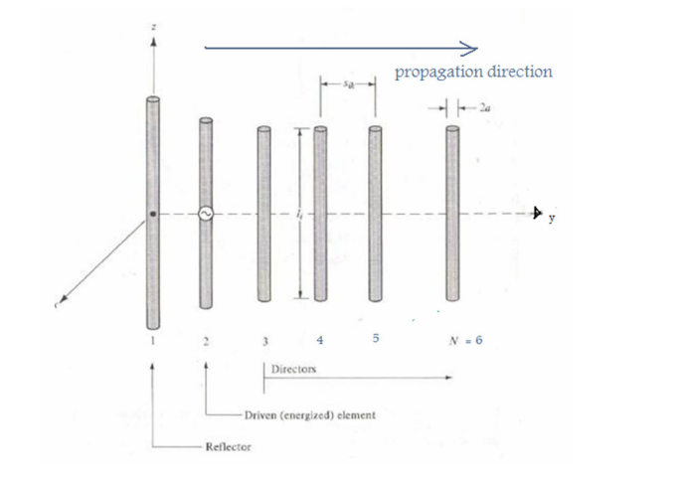

Antennas are devices that transmit or receive electromagnetic waves. If an antenna is receiving a signal, it converts the incident electromagnetic waves into electrical currents; if it is transmitting it does the opposite. Antennas are designed to radiate (or receive) electromagnetic energy with radiation and polarization properties suited for its specific application.

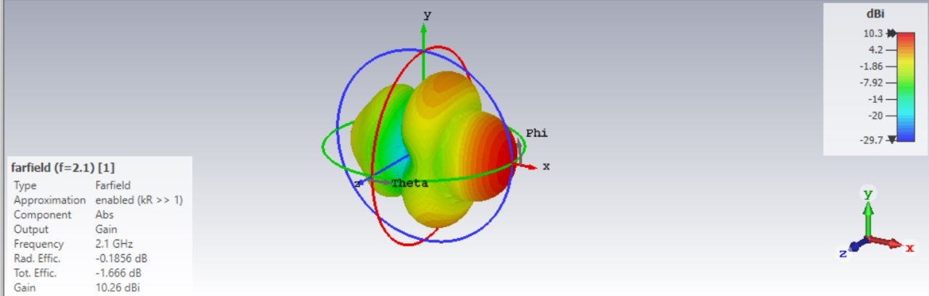

**FAR FIELD**

**PROCEDURE:**

The Yagi antenna that was built for this project was made from an aluminium sheet. The aluminium sheet was cut out using pliers and filed down to the specific dimensions. The driving element was shaped from a thin plastic sheet and then covered with copper tape. The Yagi antenna was built this way for two reasons: the aluminium sheet and copper tape were cheap and easy to work with. The drawback of cutting out the Yagi antenna from an aluminium sheet was that the design became final upon cutting and no further adjustments are then possible.

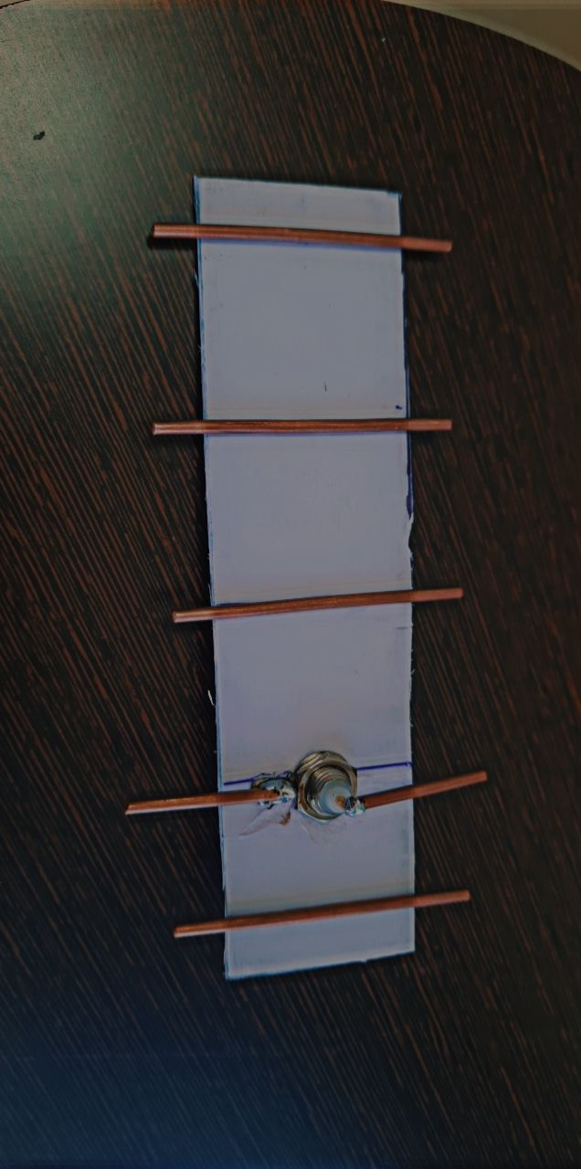

**ANTENNA**

In order to determine how our Yagi antenna would radiate we decided to use a very common software application which calculated and plotted the three-dimensional radiation patterns for typical antennas.

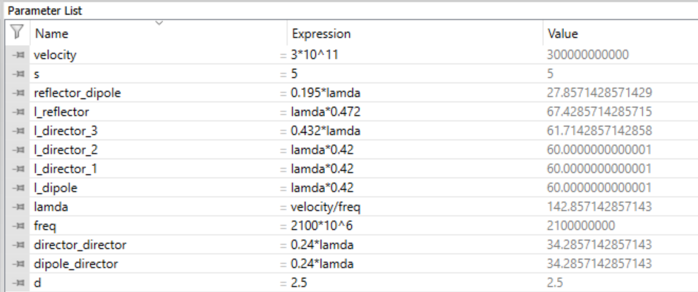

**PARAMETRIC LIST**

**RESULTS AND OBSERVATIONS:**

Once we verified that the Yagi antenna did in fact transmit then we placed it in the radiation chamber (Figure 10). Inside this chamber the antenna is mechanically rotated while an automated program gathered all the relevant data then generated a three-dimensional radiation pattern graph as shown in Figure 11. The measured radiation pattern yielded 5.54dB gain which is 0.7dB less than what we had expected.



**GAIN**

The overall gain closely correlated to the theoretical gain, which came as a surprise to us since we had not performed any matching on the antenna. The minor lobes are suppressed, and the directivity of the major lobe is increased by the addition of directors to the antenna.

The design of antenna relates to the radiation pattern which refers to the dependence of directional radiation from antenna. As Yagi Uda antenna is commonly known as Yagi and is refers as directional antenna. A radiation pattern of an antenna is a function of a graphical representation of properties of radiations of antenna as a function of space coordinates. Most of the Yagi Uda antennas are determined in the field of region and it is the function of directional coordinates. The property of radiation is either two dimension or three-dimension distributions of radiation energy. It may include power flux density, radiation intensity, field strength, directivity, or polarization.

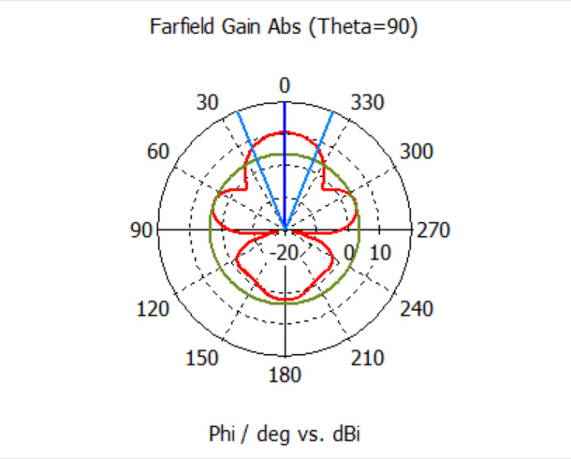 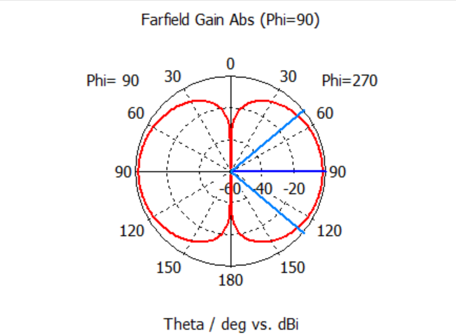

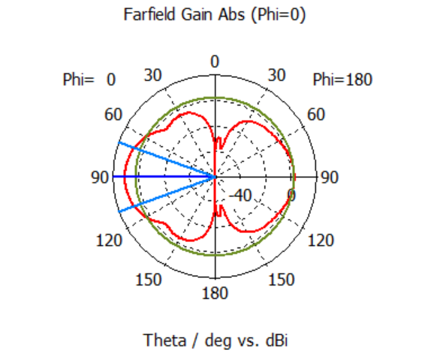

**S PARAMETERS:**

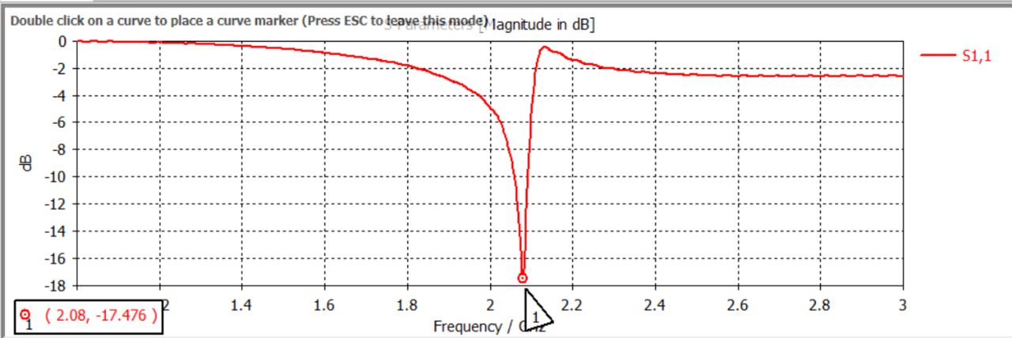

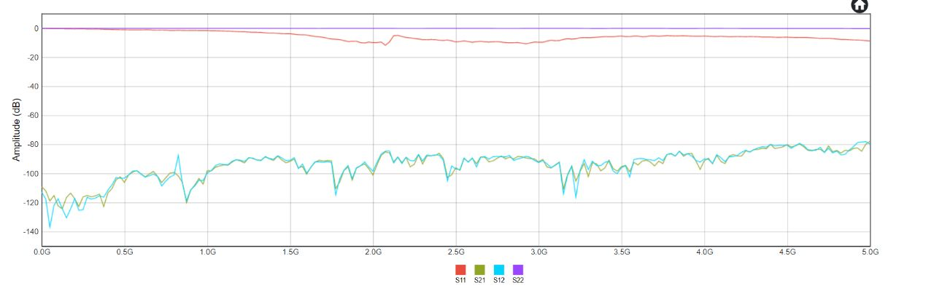

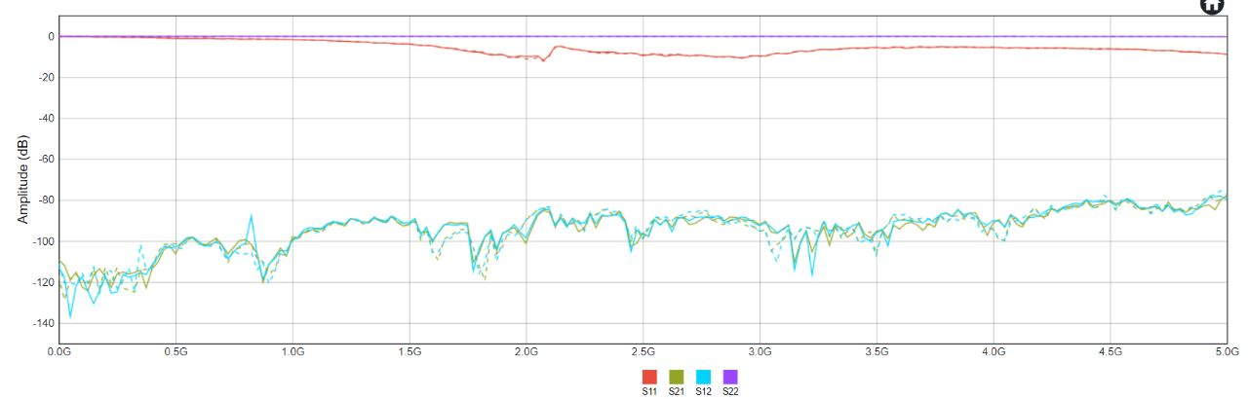

**VSWR:**

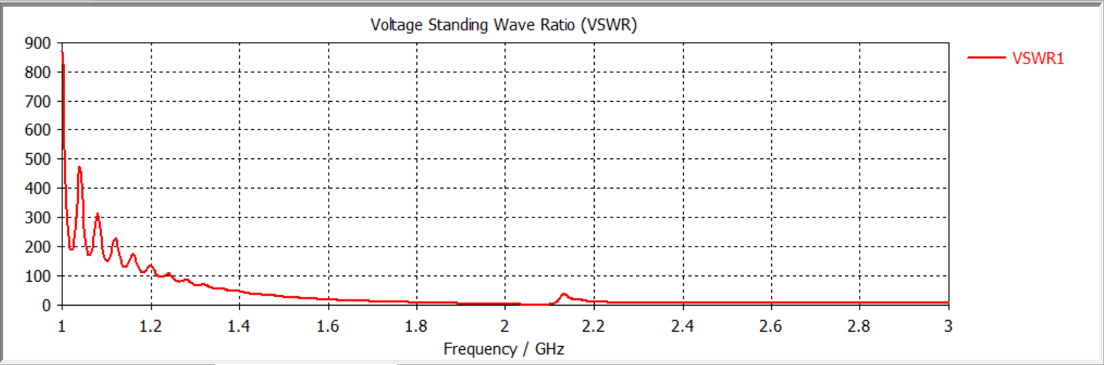

**Applications**

The following are the applications of Yagi-Uda antennas −

* Mostly used for TV reception.
* Used where a single-frequency application is needed.

**CONCLUSION:**

From the above result and observation, we can conclude that we have simulated and fabricated Yagi-uda 5 element antenna at a frequency of 2.1Ghz. And observed their s11 parameters we have analyzed and observed their outputs are similar and we have also analyzed the VSWR, Far field, Gain of the antenna respectively.